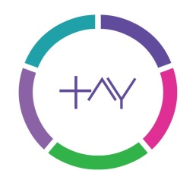
Customer Service Policy

Tay Associates is a member of the Recruitment and Employment Confederation (REC) and adheres to their Code of Professional Practice.

At Tay Associates we endeavour to provide you with the best possible service at all times. If you would like to make any comments, suggestions, raise a query or make a complaint about the service you have received, please contact us, our contact details are set out below. We will respond to your query within 24 hours.

This policy will be kept up to date, to reflect changes in the nature and size of the business. To ensure this, the policy and its effectiveness will be reviewed annually.

Courtesy
All recruitment consultants will be trained in customer service standards; will exhibit customer friendly service skills; and be knowledgeable, professional and courteous in meeting the needs of our customers.

Communication
Tay Associates staff will return all correspondence within agreed timescales. Where we are unable to meet this agreement we will inform you of this as soon as possible and agree a new deadline.

Consistency
As part of our commitment to upholding professional standards, we will review our policies annually to ensure that they continue to meet business needs and the Recruitment and Employment Confederation’s Code of Professional Practice; and that they are consistently applied to all our customers.

Complaints
Tay Associates seeks fair, just and prompt solutions when possible to any complaints and appeals. All such issues should be directed to the Office Manager in the first instance, where they will be acknowledged and directed to the attention of the appropriate person. A complaints process is in place for any disputes; copies are available from our offices or on http://www.tayassociates.com/downloads .

Access to Information
We comply fully with the provisions of the Data Protection Act 1998. Any personal or confidential information held by us about a client or work seeker is fully accessible to that person or body for review or editing by contacting the Managing Director, Susanna Tait.

Reduce Bureaucracy
Wherever possible, without compromising our legal requirements and professional standards we strive to reduce the burden of unnecessary paperwork.

How to Contact Us:
Tay Associates Limited
Tel: 02070 656 700
Email: customerservice@tayassociates.co.uk
Internet: www.tayassociates.com

